

MEDIA GUIDE
2025
TABLE OF
CONTENTS

SPONSORSHIP OPPORTUNITIES DAILY COMMENTARY PODCASTS
SHOWS BANNER / DISPLAY ADS FRIDAY ROUNDUP THOUGHT LEADERSHIP

DAILY COMMENTARY

Advertising Options
The Chrisman Commentary daily
newsletter is delivered to 80,000 mortgage professionals Monday - Saturday. The publication features six advertising slots Monday to Friday and a company spotlight available on Saturday, positioned to promote vendor products and job postings.

Inquire for rush services.

Standard Slot
Available daily, Monday - Friday, 150 words $625

Priority Ad Placement

Top placement +$300

Second placement +$200
Third placement +$100

Bulk Deals
Option 1: $600/ad for three-ﬁve commentary ads
Option 2: $575/ad for six-eight commentary ads
Option 3: $550/ad for nine or more commentary ads

Saturday Company Spotlight
600-word piece run on Saturday morning at the $600 top of the newsletter

PODCASTS

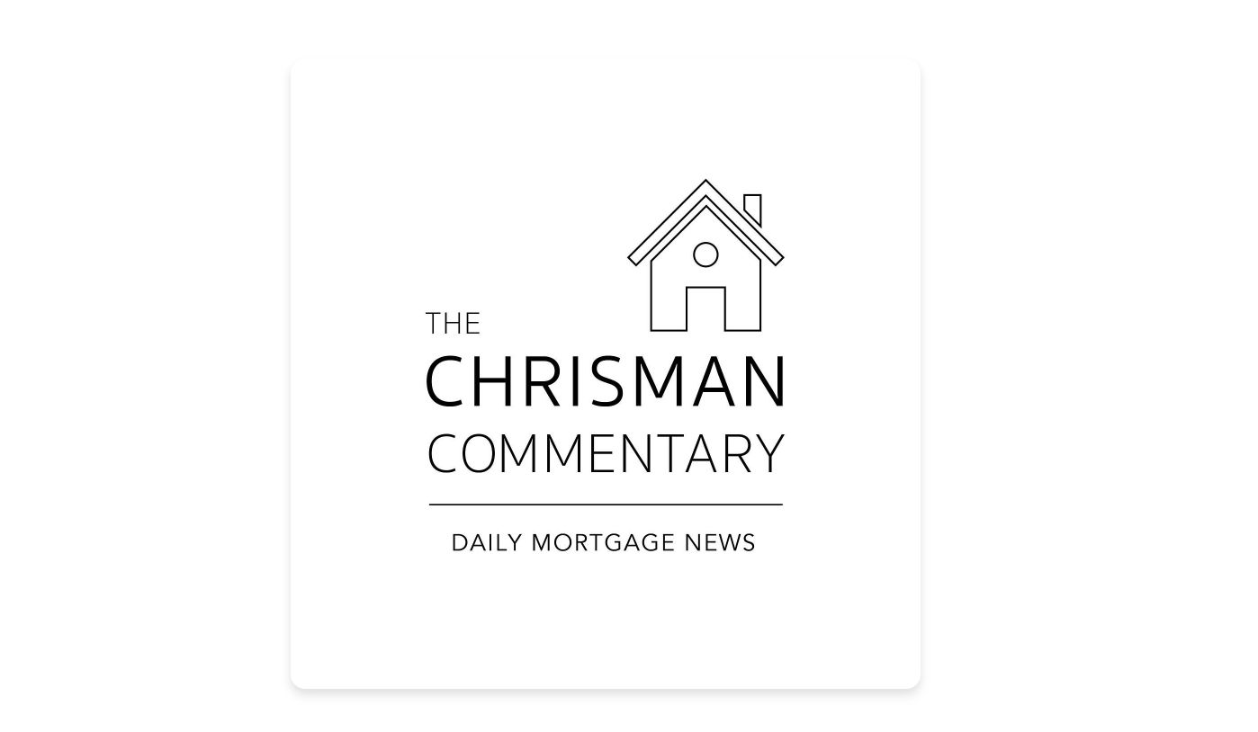The Chrisman Commentary podcast has run Monday to Friday since 2021 with nearly 1,000 episodes. Each episode receives 6,000 to 7,000 downloads, with total listens estimated to be several multitudes higher.

Sponsored interview segments normally run 10-15 minutes and allow sponsors to dictate the discussion topics.

Advertising Options
Title Sponsorship (5 episodes) Daily mention in podcast, one interview, logo in Friday Roundup
+ feature in opening paragraph of Daily Commentary

Interview Only
Four interview spots available per week

$3,995/week

$795/interview

SHOWS

Chrisman Commentary produces nine unique shows on a weekly and monthly basis, covering a range of topics while featuring key voices in the mortgage industry.
Advertising Options

Package options are available, allowing commitment for multiple weeks or months.

$1,000/show

NOW NEXT
LATER
M«DRTGAGE
J:) EJ0
CHRISMAN
COMMENTARY

Weekly, Mondays at 1:00PM ET Weekly, Tuesdays at 2:00PM ET
Weekly, Wednesdays at 2:00PM ET
No sponsorship available

.A..I...
/::~

THI BIC PICTURI
HOUSING. BUSINESS. LIFE. LEVITY!

Weekly, Thursdays at 3:00PM ET Weekly, Fridays at 1:00PM ET
CHRISMAN
C.OMMl::N Alff

ADVISORY ANG LE
STRATMORGROUP

Monthly, Tuesdays at 3:00PM ET
No sponsorship available

MORTGAGE~S ~·~_ .: ~: \
WITH MILLENNIALS ..
regulation
Central
CHRISMAN
COMMENTA~Y
I 11 1 1 I 1 1 1 1 I 1 1 , 1 I 1 , 1 , J , 111 I


Monthly, Tuesdays at 1:00PM ET
Monthly, Tuesdays at 3:00PM ET
No sponsorship available

No sponsorship available
. /CAPITAL
/Y !MARKETS
I CHRISMAN w n n p
r~MFNTARY I'"""( M
Monthly, Tuesdays at 3:00PM ET

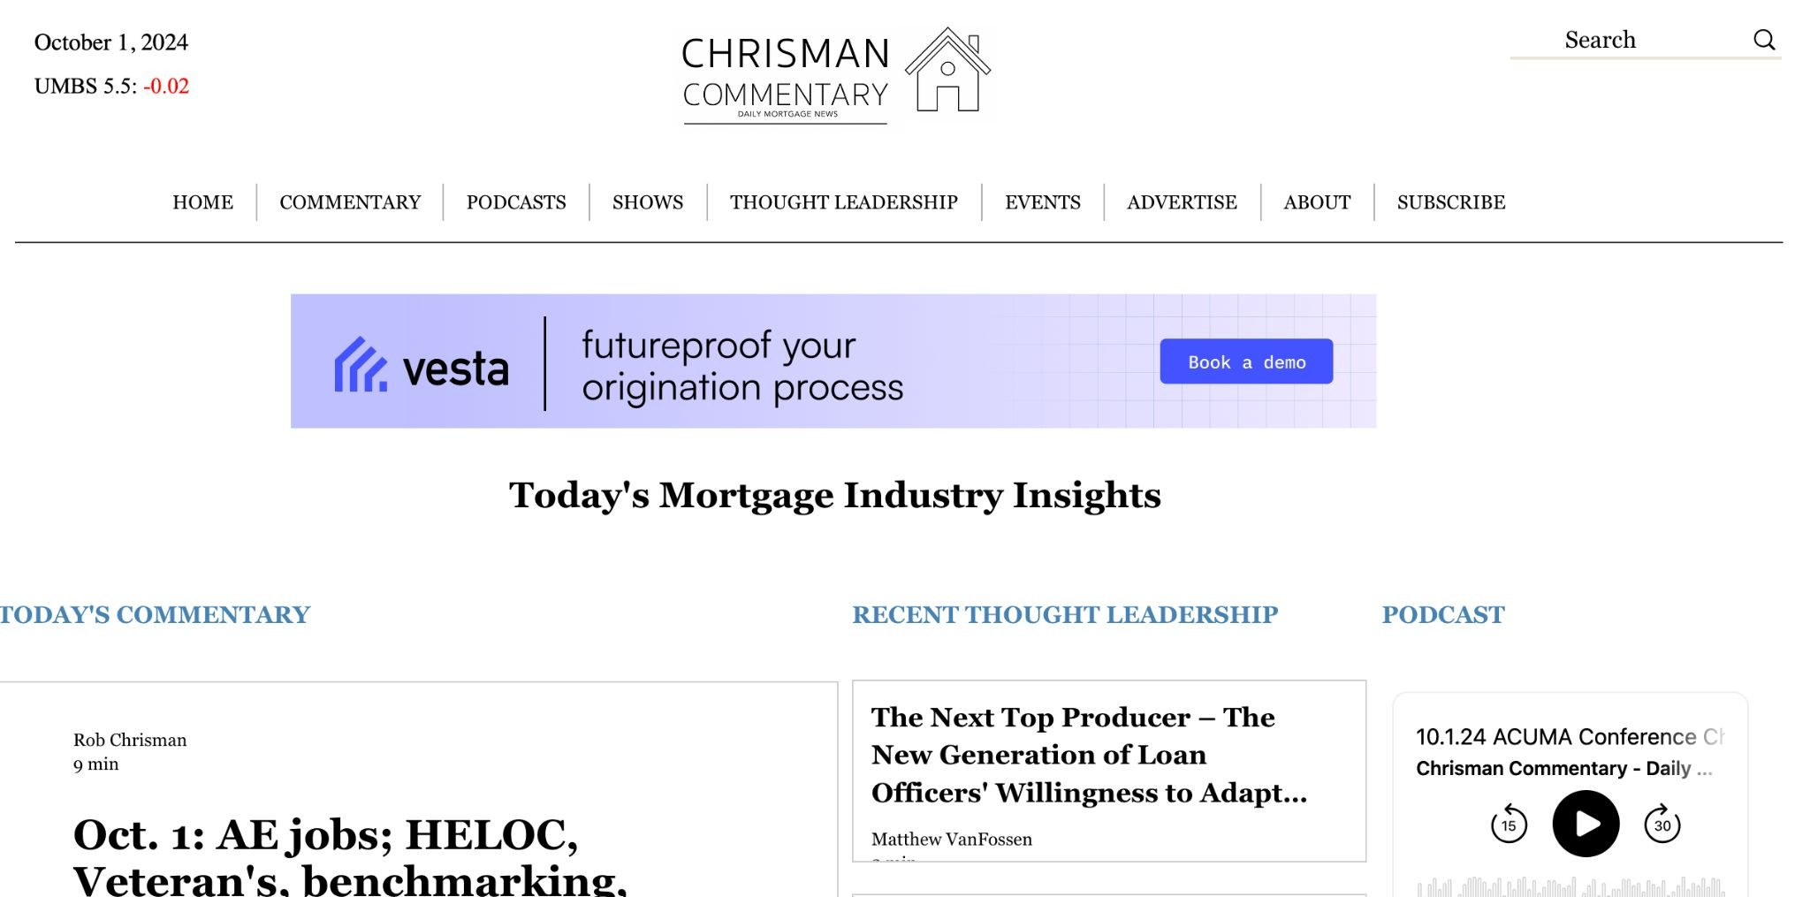
BANNER / DISPLAY ADS

Website banner ads are available on the Chrisman Commentary website on a ﬁrst-come, ﬁrst-serve basis.

Advertising Options
3-month package | $2,000
6-month package | $3,000
12-month package | $5,000

FRIDAY ROUNDUP

Distributed to 80,000 recipients every Friday, the Friday Roundup features a market overview, capital markets recap, all podcasts, thought leadership, and shows Chrisman Commentary published in the previous week, as well as a preview of mortgage industry events.

Advertising Options

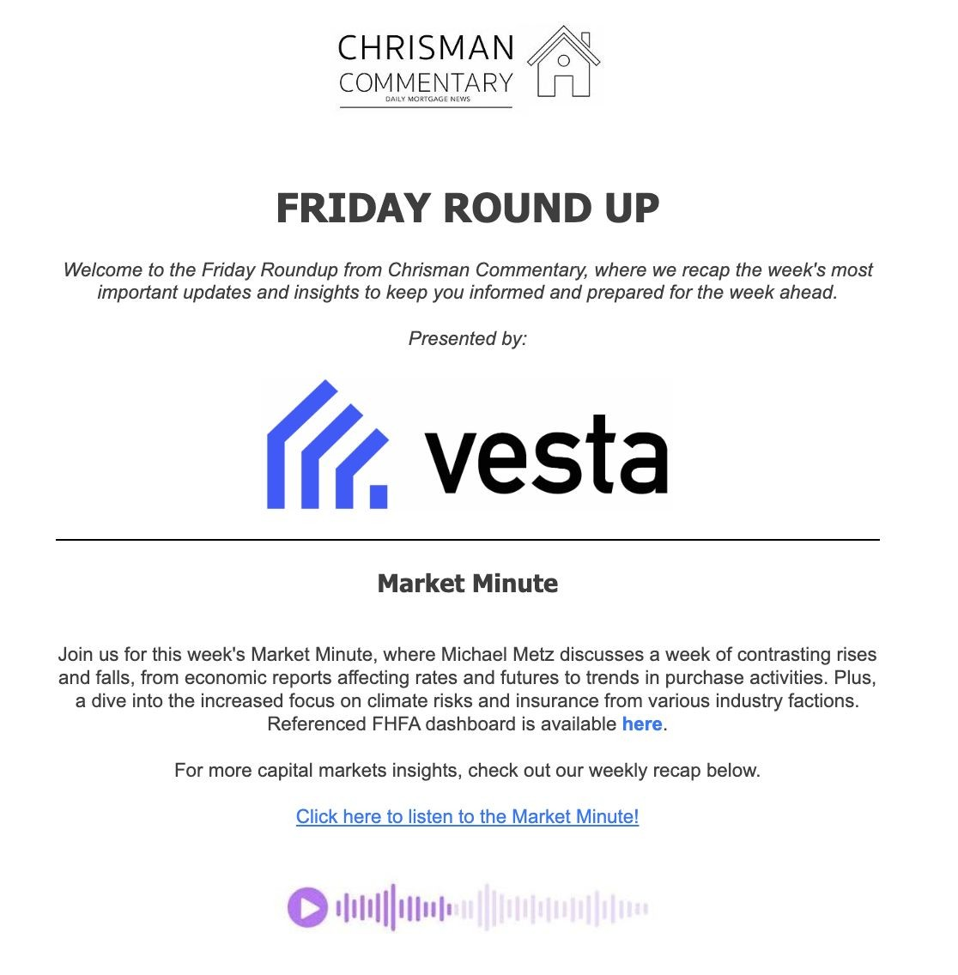Weekly sponsorship*

*booked through end of May 2025
$1,500

THOUGHT LEADERSHIP

Articles featuring commentary across a variety of categories ranging from: innovation and technology, origination happenings, breaking news, opinion, capital markets, regulatory and compliance, advisory dealings, and targeting the next generation of home buyers.

Thought Leadership sponsorship includes an advertising slot in the Friday Roundup.
Advertising Options

Weekly headline sponsorship opportunities.

Inquire for pricing

Connect with us!

info@chrismancommentary.com

